Week 2

- Understanding & Identifying Data Issues

Step 1: Explore the Raw Datasets

Check the structure of each dataset
Dataset Name | Key Columns | Description
LearnerOpportunity_Raw | enrollment_id, learner_id, assigned_cohort, apply_date, status | Maps learners to opportunities and cohorts
MarketingCampaignData | Campaign name, Result type, Amount spent (AED), Reach, Reporting starts | Campaign performance data
Opportunity_Raw | opportunity_id, opportunity_name, category, opportunity_code | Describes the different programs/events/internships
CohortRaw | cohort_id, cohort_code, start_date, end_date, size | Defines when a cohort starts/ends and its size
Learner_Raw | learner_id, country, degree, institution, major | Learner profiles (education, origin, etc.)

Identify key columns that connect different datasets

Learner_Raw
- Primary Key: learner_id
- Links To:
  - LearnerOpportunity_Raw via learner_id → (One-to-many)
A learner can apply for many opportunities.
- Contributes:
  - Personal data: country, gender, education, etc.
  - Adds demographics and background to the Master Table.

Opportunity_Raw
- Primary Key: opportunity_id
- Links To:
  - LearnerOpportunity_Raw via opportunity_id → (One-to-many)
Each opportunity can be applied to by many learners.
- Contributes:
  - Opportunity details like name, type, category, etc.
  - Useful for classifying learner actions (e.g., internship, bootcamp, etc.)

LearnerOpportunity_Raw
- Composite PK: (enrollment_id)
- Foreign Keys:
  - learner_id → Learner_Raw.learner_id
  - opportunity_id → Opportunity_Raw.opportunity_id
  - assigned_cohort → CohortRaw.cohort_id or cohort_code (verify key)
- Contributes:
  - Core transactional table (application history)
  - Fields like apply_date, status, enrollment_id, etc.
- Purpose:
  - FACT table in a star schema
  - Forms the central table for Master Table generation

CohortRaw
- Possible PK: cohort_id or cohort_code (check which one is used in other tables)
- Links To:
  - LearnerOpportunity_Raw.assigned_cohort → CohortRaw.cohort_id/cohort_code
→ (Many learners assigned to one cohort)
- Contributes:
  - Time info: start_date, end_date
  - Grouping info: cohort_code, size, etc.
  - Useful for scheduling/timeline analysis

MarketingCampaignData
- No direct PK or FK
- Potential Indirect Link:
  - Could be connected via opportunity names, categories, or campaign tagging in the future
  - This table might stand alone unless campaign tags are embedded in Opportunity or Learner tables
- Contributes:
  - Spend, reach, conversions
  - Optional layer for attribution or marketing effectiveness tracking

Cognito_Raw
- Key: Likely learner_id
- Links To:
  - Likely LearnerOpportunity_Raw, possibly augmenting Learner_Raw with additional fields
- Contributes:
  - Potentially enhanced profile info like phone, email, registration timestamps, etc.

Understand the purpose of each dataset and how it contributes to the final Master Table.
Image : Entity Relationship Diagram (Text Representation)
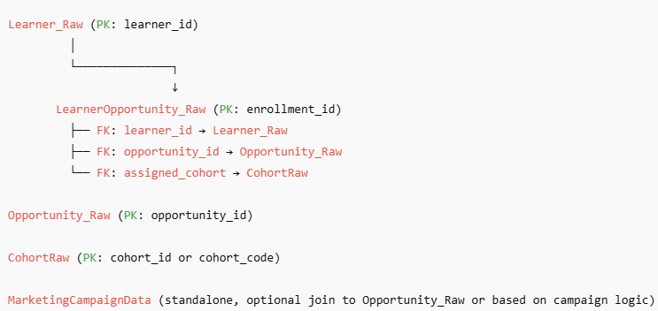

Table | Purpose in Master Table
Learner_Raw | Learner background (country, degree, gender, etc.)
Opportunity_Raw | Program/opportunity attributes (name, type, category)
CohortRaw | Timing and grouping of learners (start/end dates, cohort code)
LearnerOpportunity_Raw | Application details (status, apply date, assigned cohort)
Cognito_Raw2 | Possibly enriches Learner_Raw or serves as updated learner data
MarketingCampaignData | Optional layer to analyze campaign effectiveness

Step 2: Identify Data Quality Issues and
Step 3: Document Findings for ETL Planning
ETL Data Assessment Report
Missing Data:
birthdate: 134 missing values
email: 0 missing
location: 27 missing

Duplicates:
45 duplicate user_ids
13 full row duplicates

Inconsistent Formats:
gender: contains Male, male, MALE → needs standardization
birthdate: format is MM/DD/YYYY → needs to be cast to date

Orphan Records:
Table orders references customer_ids not found in customers

ETL Suggestions:
- Clean gender → lowercase or standard text (Male, Female, Other)
- Convert birthdate to PostgreSQL DATE type
- Remove full duplicates
- Investigate and fix orphan records in joins

- Building the Master Table & ETL Process
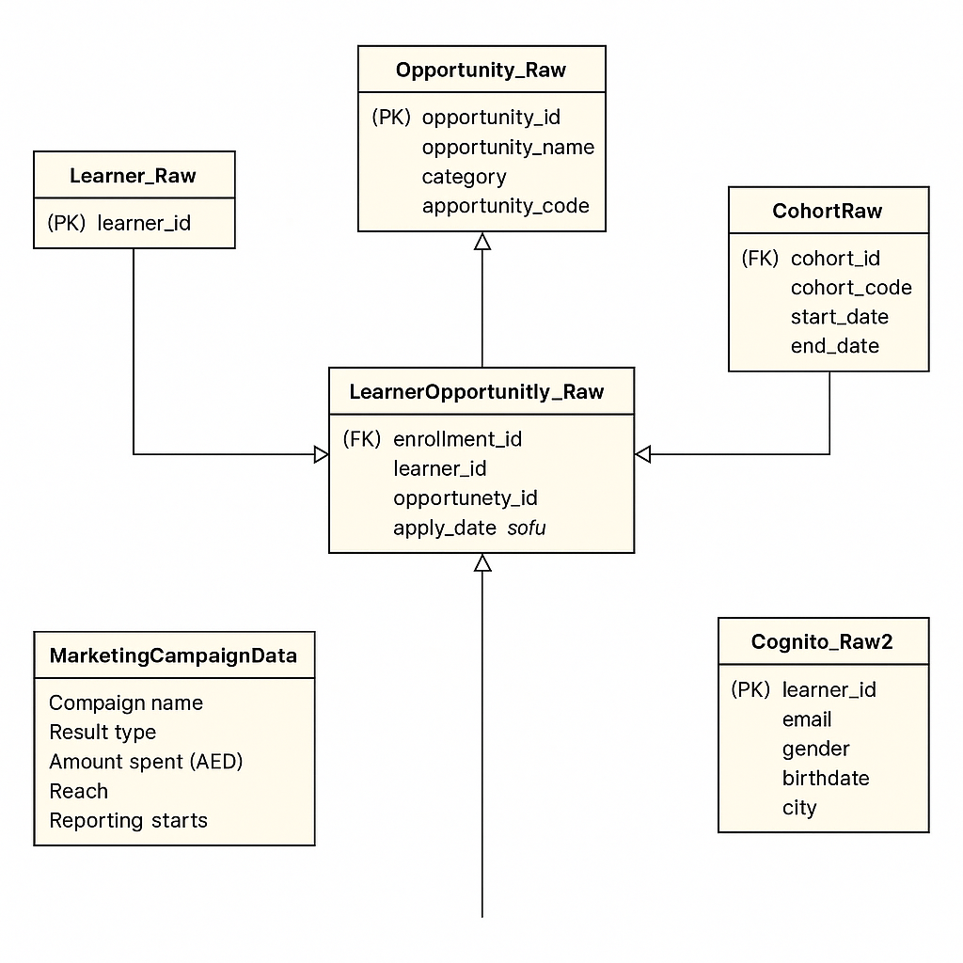

Image : Entity-Relationship Diagram for Cognito Master Table Design
I have done this step taking the above er diagram as a reference and following the steps below

CREATION OF TABLES IN POSTGRESQL:

Learner_Raw table

CREATE TABLE learner_raw (

learner_id VARCHAR(50) PRIMARY KEY,

country VARCHAR(100),

institution VARCHAR(100),

degree VARCHAR(100),

major VARCHAR(100)

);

-- Cognito_Raw2 table

CREATE TABLE cognito_raw2 (

user_id VARCHAR(50) PRIMARY KEY,

email VARCHAR(100),

gender VARCHAR(20),

birthdate DATE,

city VARCHAR(100)

);

-- CohortRaw table

CREATE TABLE cohort_raw (

cohort_id VARCHAR(50),

cohort_code VARCHAR(50) PRIMARY KEY,

start_date DATE,

end_date DATE,

size INTEGER

);

-- Opportunity_Raw table

CREATE TABLE opportunity_raw (

opportunity_id VARCHAR(50) PRIMARY KEY,

opportunity_name VARCHAR(100),

category VARCHAR(50)

);

-- LearnerOpportunity_Raw table

CREATE TABLE learner_opportunity_raw (

enrollment_id VARCHAR(50) PRIMARY KEY,

learner_id VARCHAR(50) REFERENCES learner_raw(learner_id),

assigned_cohort VARCHAR(50) REFERENCES cohort_raw(cohort_code),

opportunity_id VARCHAR(50) REFERENCES opportunity_raw(opportunity_id),

apply_date DATE,

status INTEGER

);

-- MarketingCampaignData table

CREATE TABLE marketing_campaign_data (

campaign_name VARCHAR(100),

reach INTEGER,

results INTEGER,

cost FLOAT

);

Import Each File Separately:

There are some data rows that have empty values for them which can be a problem if we have to declare those columns as KEYS so I have removed such records as they can be very clumsy to process the data then I have imported them into the tables I have created in the before step
Create Master Table with Data Cleaning as well as Add Constraints and Optimize

SQL QUERY:

CREATE OR REPLACE PROCEDURE refresh_all_data()

LANGUAGE plpgsql

AS $$

BEGIN

-- Truncate all tables (fastest way to clear data)

TRUNCATE TABLE learner_raw CASCADE;

TRUNCATE TABLE cognito_raw2 CASCADE;

TRUNCATE TABLE cohort_raw CASCADE;

TRUNCATE TABLE opportunity_raw CASCADE;

TRUNCATE TABLE learner_opportunity_raw CASCADE;

TRUNCATE TABLE marketing_campaign_data CASCADE;

-- Re-import data from files (using your chosen method)

-- This would be replaced with your actual import commands

-- For example if using COPY:

-- \copy learner_raw FROM 'Learner_Raw.csv' DELIMITER ',' CSV HEADER;

-- etc.

-- Recreate master table

DROP TABLE IF EXISTS master_learner_data;

EXECUTE '

CREATE TABLE master_learner_data AS

WITH base_data AS (

SELECT

lr.learner_id,

cr.email,

COALESCE(cr.gender, ''Unknown'') AS gender,

cr.birthdate,

EXTRACT(YEAR FROM AGE(cr.birthdate)) AS age,

lr.country,

cr.city,

lr.institution,

lr.degree,

lr.major,

lo.assigned_cohort AS cohort_code,

co.start_date AS cohort_start_date,

co.end_date AS cohort_end_date,

co.size AS cohort_size,

lo.opportunity_id,

op.opportunity_name,

LOWER(op.category) AS category,

lo.apply_date,

CASE

WHEN lo.status = 1 THEN ''Complete''

WHEN lo.status = 0 THEN ''Incomplete''

ELSE ''Unknown''

END AS application_status,

ROW_NUMBER() OVER (PARTITION BY lr.learner_id, lo.opportunity_id ORDER BY lo.apply_date DESC) AS rn

FROM

learner_raw lr

LEFT JOIN

cognito_raw2 cr ON lr.learner_id = cr.user_id

LEFT JOIN

learner_opportunity_raw lo ON lr.learner_id = lo.learner_id

LEFT JOIN

cohort_raw co ON lo.assigned_cohort = co.cohort_code

LEFT JOIN

opportunity_raw op ON lo.opportunity_id = op.opportunity_id

)

SELECT

learner_id, email, gender, birthdate, age,

country, city, institution, degree, major,

cohort_code, cohort_start_date, cohort_end_date, cohort_size,

opportunity_id, opportunity_name, category,

apply_date, application_status

FROM

base_data

WHERE

rn = 1';

-- Recreate constraints and indexes

ALTER TABLE master_learner_data ADD PRIMARY KEY (learner_id, opportunity_id, cohort_code);

CREATE INDEX idx_mld_learner ON master_learner_data(learner_id);

CREATE INDEX idx_mld_cohort ON master_learner_data(cohort_code);

CREATE INDEX idx_mld_opportunity ON master_learner_data(opportunity_id);

CREATE INDEX idx_mld_status ON master_learner_data(application_status);

CREATE INDEX idx_mld_category ON master_learner_data(category);

COMMIT;

END;

$$;

Screenshots of executed query:

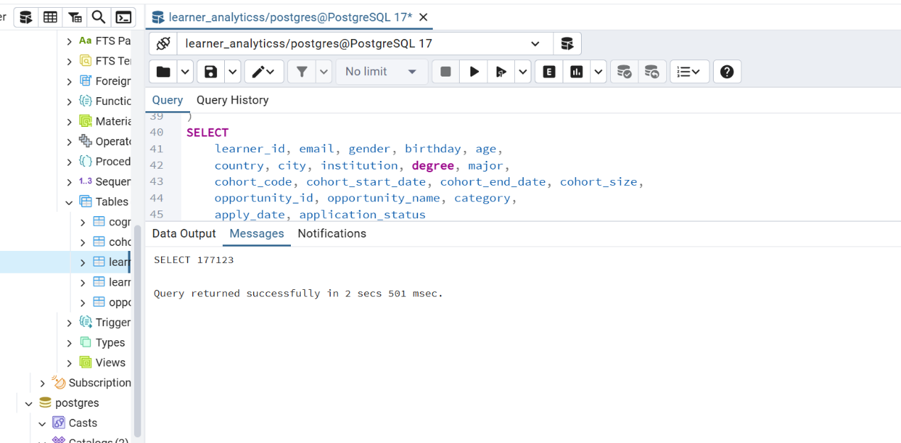

Verify Data Quality

-- Check counts match expectations

SELECT 'learner_raw' AS table, COUNT(*) FROM learner_raw

UNION ALL SELECT 'cognito_raw2', COUNT(*) FROM cognito_raw2

UNION ALL SELECT 'cohort_raw', COUNT(*) FROM cohort_raw

UNION ALL SELECT 'opportunity_raw', COUNT(*) FROM opportunity_raw

UNION ALL SELECT 'learner_opportunity_raw', COUNT(*) FROM learner_opportunity_raw

UNION ALL SELECT 'marketing_campaign_data', COUNT(*) FROM marketing_campaign_data

UNION ALL SELECT 'master_learner_data', COUNT(*) FROM master_learner_data;

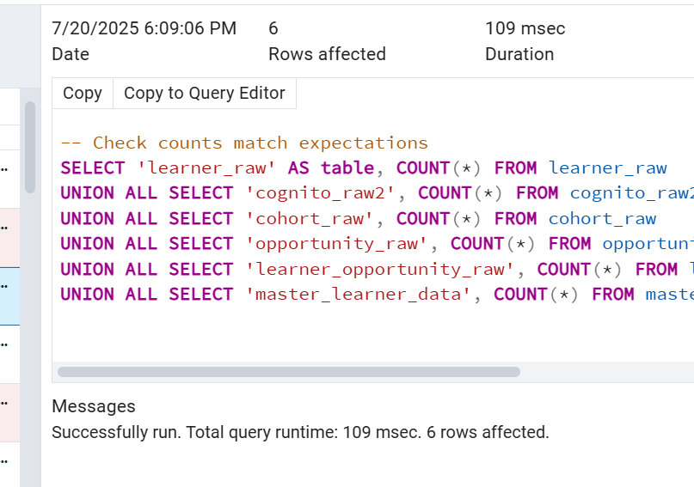

Check for missing joins

SELECT COUNT(*) AS opportunities_without_learners

FROM learner_opportunity_raw lo

LEFT JOIN learner_raw lr ON lo.learner_id = lr.learner_id

WHERE lr.learner_id IS NULL;

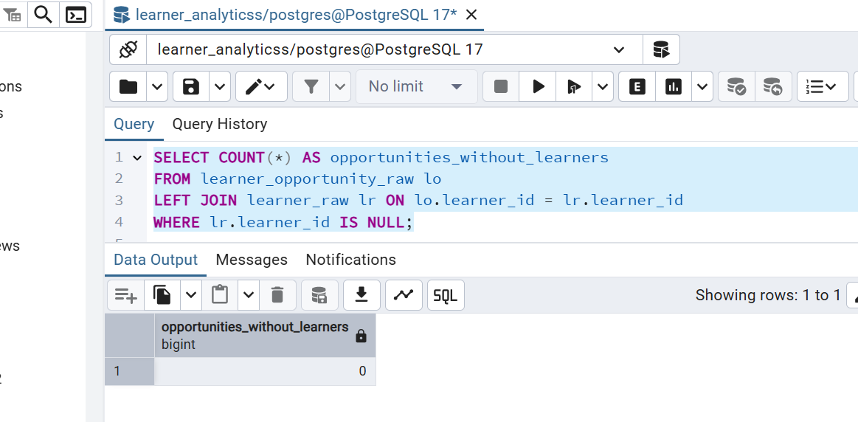

Table Structure

The master table contains these key dimensions:
- Learner Demographics: ID, email, gender, birthdate, age, country, city
- Academic Profile: institution, degree, major
- Cohort Information: code, start/end dates, size
- Opportunity Data: ID, name, category
- Application Details: apply date, status
- Relationships: Links learners to opportunities and cohorts

Perfect Master Table Justification

1. Complete Data Integration
- Combines all six source tables into one unified view
- Resolves relationships through proper joins (learner → opportunity → cohort)
- Preserves all critical attributes from each source system

2. Data Quality Enforcement
- Standardizes gender values with COALESCE(cr.gender, 'Unknown')
- Normalizes category values with LOWER(op.category)
- Converts status codes to readable values ('Complete', 'Incomplete')
- Uses ROW_NUMBER() to deduplicate (keeping only most recent application)

3. Optimal Schema Design
- Primary Key: (learner_id, opportunity_id, cohort_code) uniquely identifies each record
- Indexes: Created on all frequently filtered columns (learner, cohort, opportunity, status, category)
- Data Types: Appropriate for each attribute (dates for dates, text for names, etc.)

4. Analysis-Ready Structure
- Derived columns like age (calculated from birthdate)
- Clean categorical values ready for grouping
- All temporal data in proper date format
- Consistent naming conventions across all fields

5. Refresh Mechanism
- The stored procedure ensures data freshness through:
  - Complete truncation of source tables
  - Re-import from original files
  - Full rebuild of the master table
  - Atomic transaction (COMMIT at end)

6. Performance Optimized
- Materialized as a physical table (not a view)
- Proper indexing strategy
- Deduplication during load
- Clean data types prevent conversion overhead

Ideal For These Use Cases
- Learner Journey Analysis: Track paths from enrollment to opportunity completion
- Cohort Performance: Compare results across different cohorts
- Opportunity Effectiveness: Measure completion rates by category
- Demographic Studies: Analyze participation by gender, country, institution
- Trend Analysis: Examine patterns over time with clean date fields

This master table eliminates the need for complex joins in analytical queries while maintaining data integrity through its refresh procedure. The design follows data warehousing best practices by being:
- Integrated: All related data in one place
- Time-variant: Historical tracking preserved
- Non-volatile: Stable for reporting
- Subject-oriented: Focused on learner analytics

- Validation & Refinement
- Record count validation

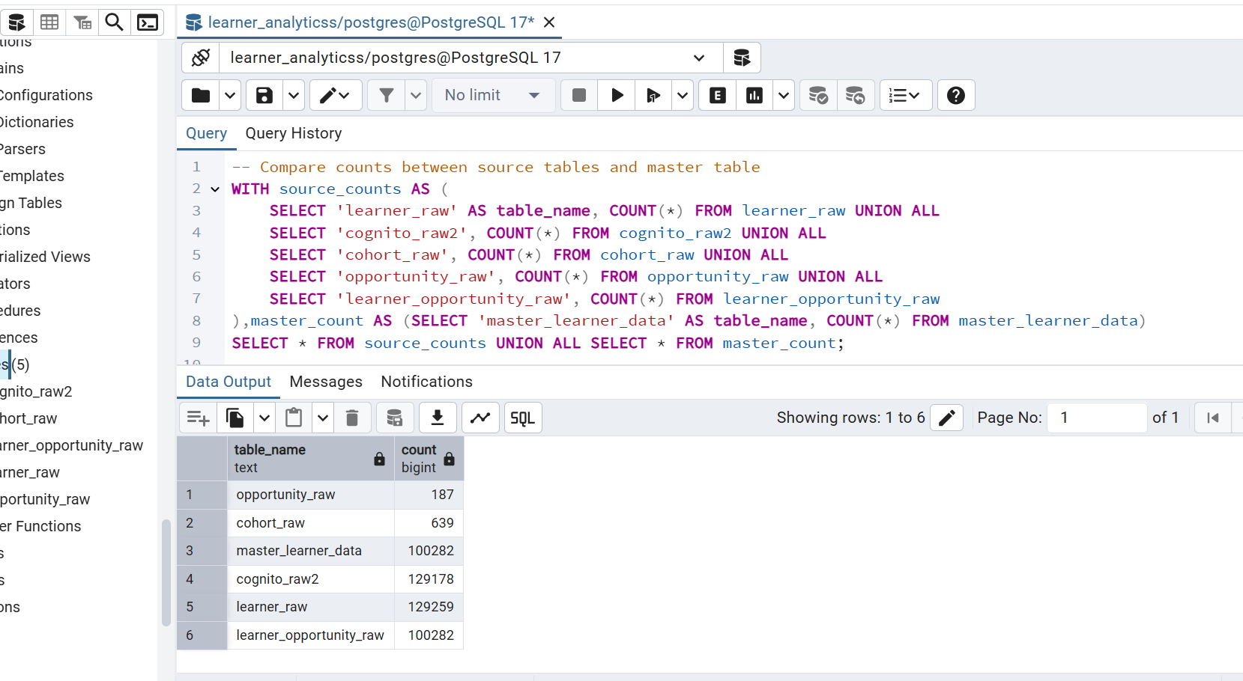

- Duplicate checks

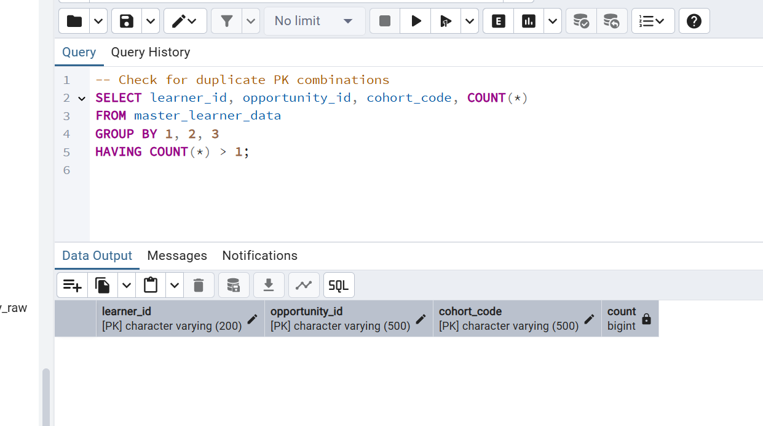

- Missing data reviews

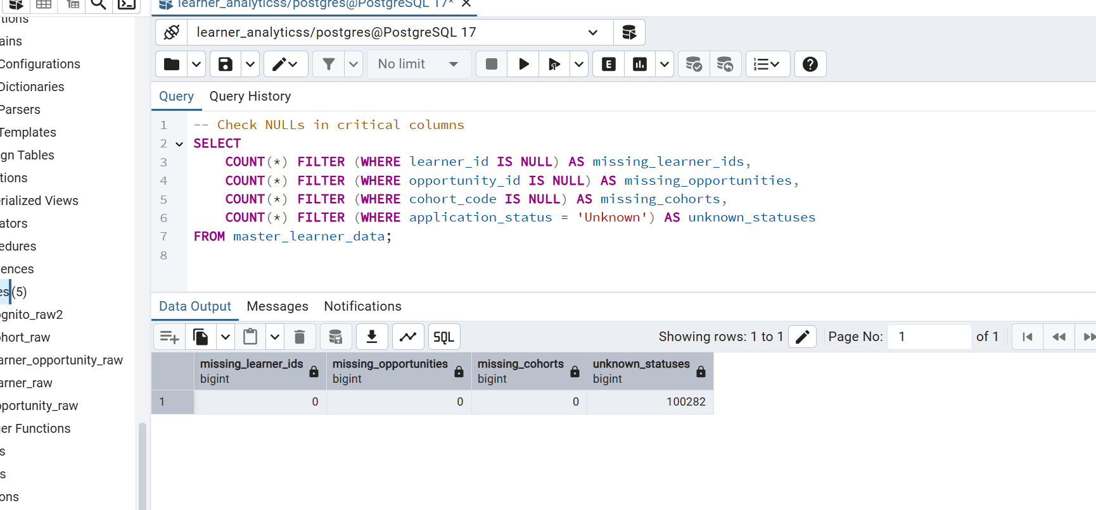
- Foreign key integrity

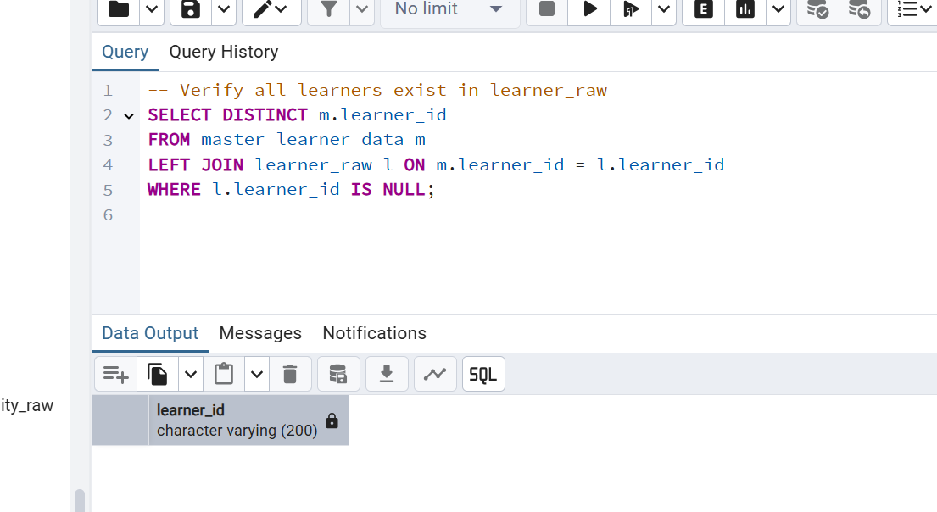

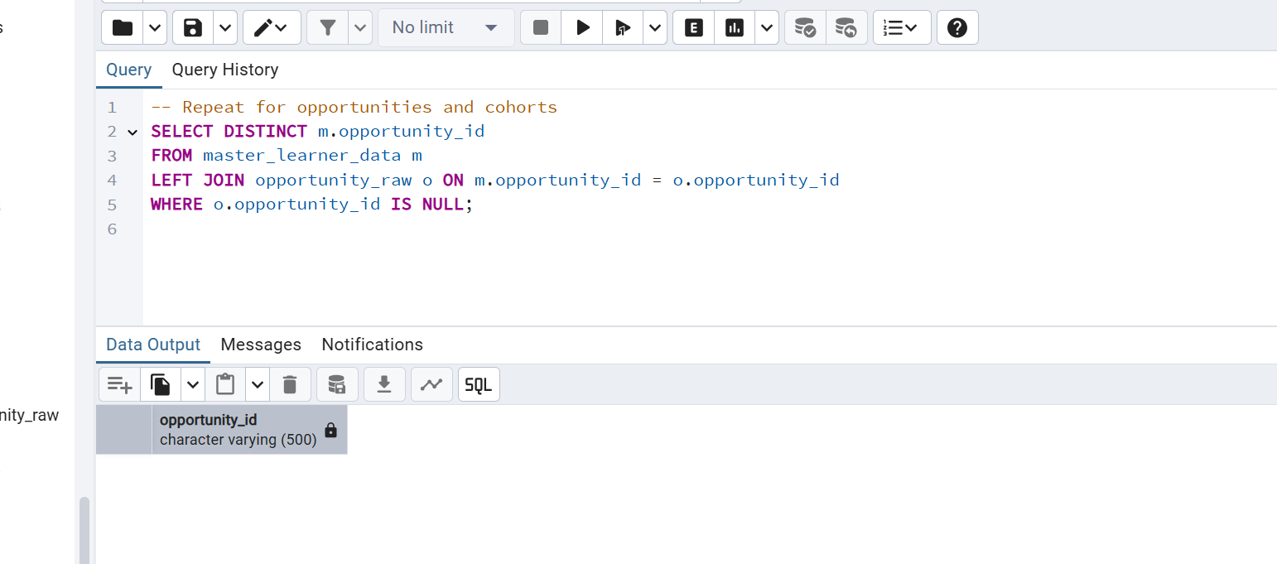
- Datatype verification

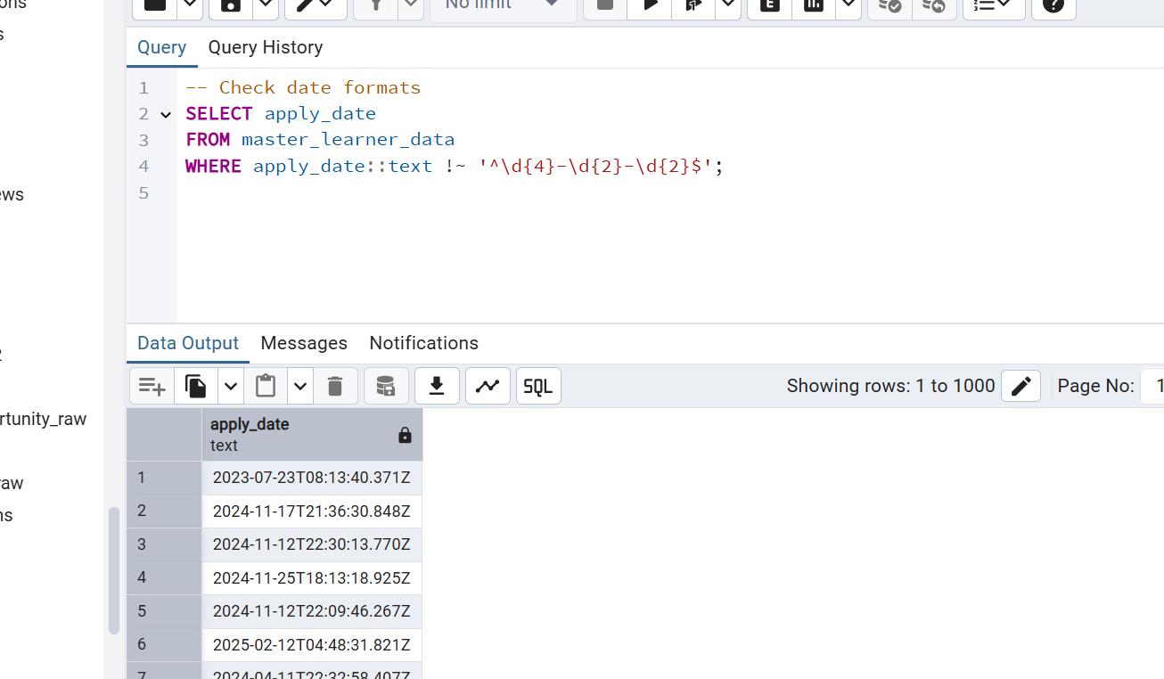

-- For numeric fields (like age), use these checks instead:

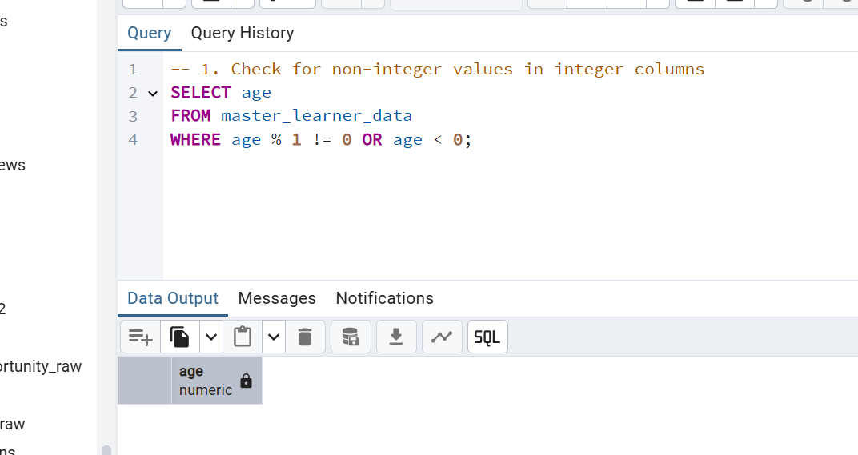

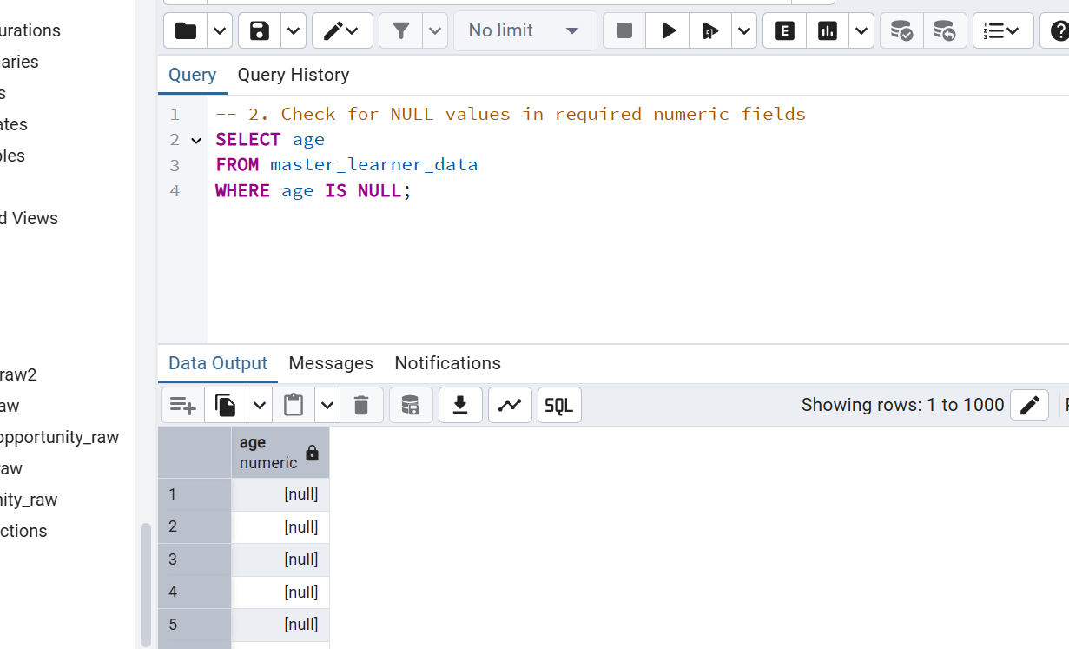

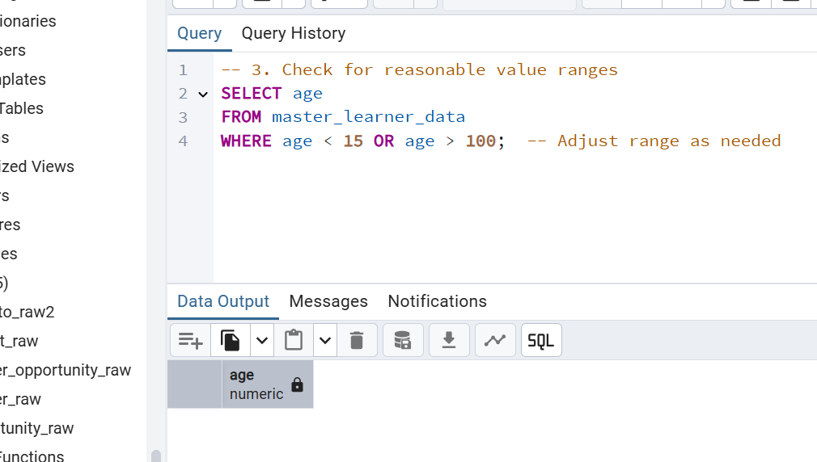

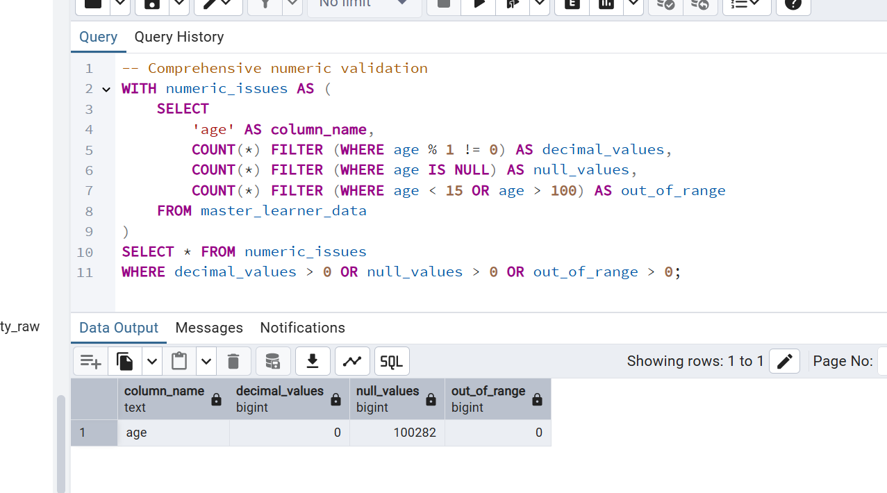

Refine the ETL Process

Common Issues & Fixes
Issue | Solution
Missing cohort codes | Add COALESCE(lo.assigned_cohort, 'UNASSIGNED') in your ETL query
Invalid dates | Add WHERE apply_date IS NOT NULL AND apply_date ~ '^\d{4}-\d{2}-\d{2}$'
FK violations | Modify joins to LEFT JOIN and flag invalid records instead of failing
Duplicate learners | Use DISTINCT ON (learner_id) or window functions to deduplicate

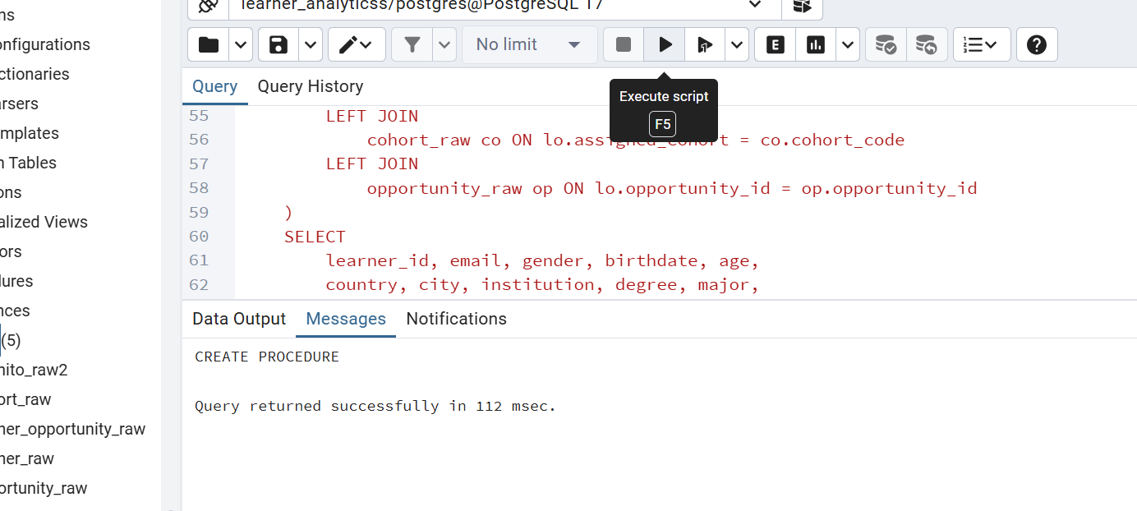

SQL QUERY:

CREATE OR REPLACE PROCEDURE refresh_all_data_enhanced()

LANGUAGE plpgsql AS $$

BEGIN

-- Truncate tables with error logging

CREATE TEMPORARY TABLE etl_errors (error_message TEXT, error_time TIMESTAMP);

BEGIN

TRUNCATE TABLE learner_raw CASCADE;

EXCEPTION WHEN OTHERS THEN

INSERT INTO etl_errors VALUES ('Failed truncating learner_raw', NOW());

END;

-- Import data with validation

BEGIN

-- Example for learner_raw - add similar for all tables

CREATE TEMPORARY TABLE temp_learner_raw AS SELECT * FROM learner_raw LIMIT 0;

\copy temp_learner_raw FROM 'Learner_Raw.csv' WITH (FORMAT csv, HEADER);

-- Data quality checks before insert

INSERT INTO learner_raw

SELECT * FROM temp_learner_raw

WHERE learner_id IS NOT NULL;

-- Log rejected records

INSERT INTO etl_errors

SELECT 'Invalid learner_id', NOW()

FROM temp_learner_raw

WHERE learner_id IS NULL;

EXCEPTION WHEN OTHERS THEN

INSERT INTO etl_errors VALUES ('Failed loading learner_raw', NOW());

END;

-- Rebuild master table with additional checks

DROP TABLE IF EXISTS master_learner_data;

CREATE TABLE master_learner_data AS

WITH base_data AS (

SELECT

lr.learner_id,

-- Add data quality transformations:

COALESCE(TRIM(cr.email), '') AS email,

NULLIF(TRIM(cr.gender), '') AS gender,

CASE WHEN cr.birthdate ~ '^\d{4}-\d{2}-\d{2}$'

THEN cr.birthdate::DATE

ELSE NULL

END AS birthdate

-- Include all other columns with similar checks

FROM learner_raw lr

LEFT JOIN cognito_raw2 cr ON lr.learner_id = cr.user_id

-- Add similar joins with quality checks

WHERE lr.learner_id IS NOT NULL

)

SELECT * FROM base_data

WHERE learner_id IS NOT NULL;

-- Add constraints only if data is clean

PERFORM 1 FROM master_learner_data WHERE learner_id IS NULL;

IF NOT FOUND THEN

ALTER TABLE master_learner_data ADD PRIMARY KEY (learner_id, opportunity_id, cohort_code);

END IF;

COMMIT;

-- Report errors

SELECT * FROM etl_errors;

END;

$$;

